Donut Delights Cover Letter

Mr. Furballski before I begin talking about my design proposals I’d like to thank you for taking the time to consider my web designs for your company. My first design is pretty simple design that has the goal of showing people just enough to get them interested in coming in. Here’s a screenshot of the homepage.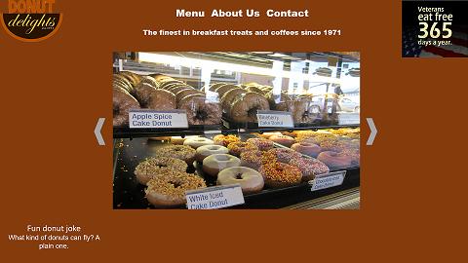 As you can see the homepage is very simple there’s not much text there except for your tagline and a little donut joke along with a carousel of images showcasing your donuts. There is also the veterans eat free gif in the top right which I thought would be a good place since this page is the first one people will see when they visit the website. Another thing I might add is that your logo doubles as a home button so when your customers are clicking around to the other pages on your site they can just click your logo and it’ll bring them right on back home. The rest of the site follows this format keeping the text short and sweet, so people can find what they are looking for and get right into the shop. Now for my second design I went for a different approach. I chose colors that would pop out to the user to get them interested in the site and thus your business. I also included more text to allow people to get a better idea of what donut delights was about. Here’s a screenshot of the 2nd designs homepage.

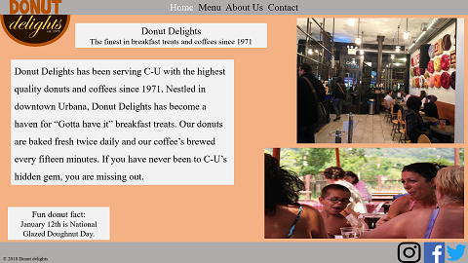As you can see compared to the first designs homepage there is much more text along with a couple of people enjoying your donuts giving people a sense of welcome when they visit the site. The rest of the pages in this design follow this same design as the home page with text to let people know about your bussiness and pictures to give them a visual representation of what the text is conveying. This was a breif description of my two design options for your bussiness and I ‘d like to thank you for taking the time to look them over. I look forward to hearing back from you.